AGENDA: LIBRARY BOARD MEETING
Tuesday, February 11, 2025 at 6 p.m.
At the Sioux Rapids Memorial Library

CALL MEETING TO ORDER

APPROVE AGENDA
- Approve minutes from previous meeting
- Approve monthly bills/financial report

DISCUSSION AND ACTION ITEMS
- Board CE classes reported
- Prohibition Program discussion/decision – where to have the program
- Erate for new year, status of last form?
- Discussion & Decision about Closing policy
- Discussion & Decision about Janitorial policy in handbook
- Budget/moving update from council meeting
- Director reporting

ADJOURNMENT

Next meeting to be March 11, 2025 @ 6:00 p.m.

2-11-25 Minutes for Sioux Rapids Public Library

PRESENT: Denise, Jamie, Dorothy, and Suzie

Called to order at 6:03 pm

- Approved minutes—Dorothy approved, Jamie seconded
- Approve monthly bills/financial report—approved
- Board CE classes—none
- Prohibition Program—possibly could do in new Library—Theatre is the first choice—Dorothy talked to Ginny.
- E-rate for the new year—471 form still needs to be done
- Discussion & Decision about closing policy—School closed, Library Closed—Leave it up to Librarian to decide whether to be open or not. Motion—Denise—Seconded by Jamie
- Discussion regarding Janitorial policy—vote to eliminate that section of the handbook. Common sense as to when it should be cleaned.
- Budget/moving update for the council meeting—budget accepted by council. Moving-- possibly not moving for 18 months due to FEMA regulations.
- Director reporting—Wed. 2-12-25 Coffee with the Director 9-10am
Daycare Storytime Friday morning
Wednesday 1:30pm Story time with TK at the school.
Program ideas:
Daddy/Daughter Dance—ask Jim or Aaron if Fire Station can be used.
Adult Prom—could do a theme
Bingo—adult—maybe have baskets donated for prizes
Ag

Sioux Rapids Memorial Library FEBRUARY 2025 Claims Report

Bills Paid After Meeting JANUARY Meeting
Alliant Energy-01-06-25 | $361.05
Total $361.05

Bills Needing Approved for Payment
Evertek, Inc. 02-01-2025 | $57.48
GCF Leasing 03/05-04/03/25 | $105.31
Baker & Taylor | $34.97
Baker & Taylor | $150.55
HRS Hanigan Writing Services | $50.00
Postage - Petty Cash January | $0.73
Total $399.04
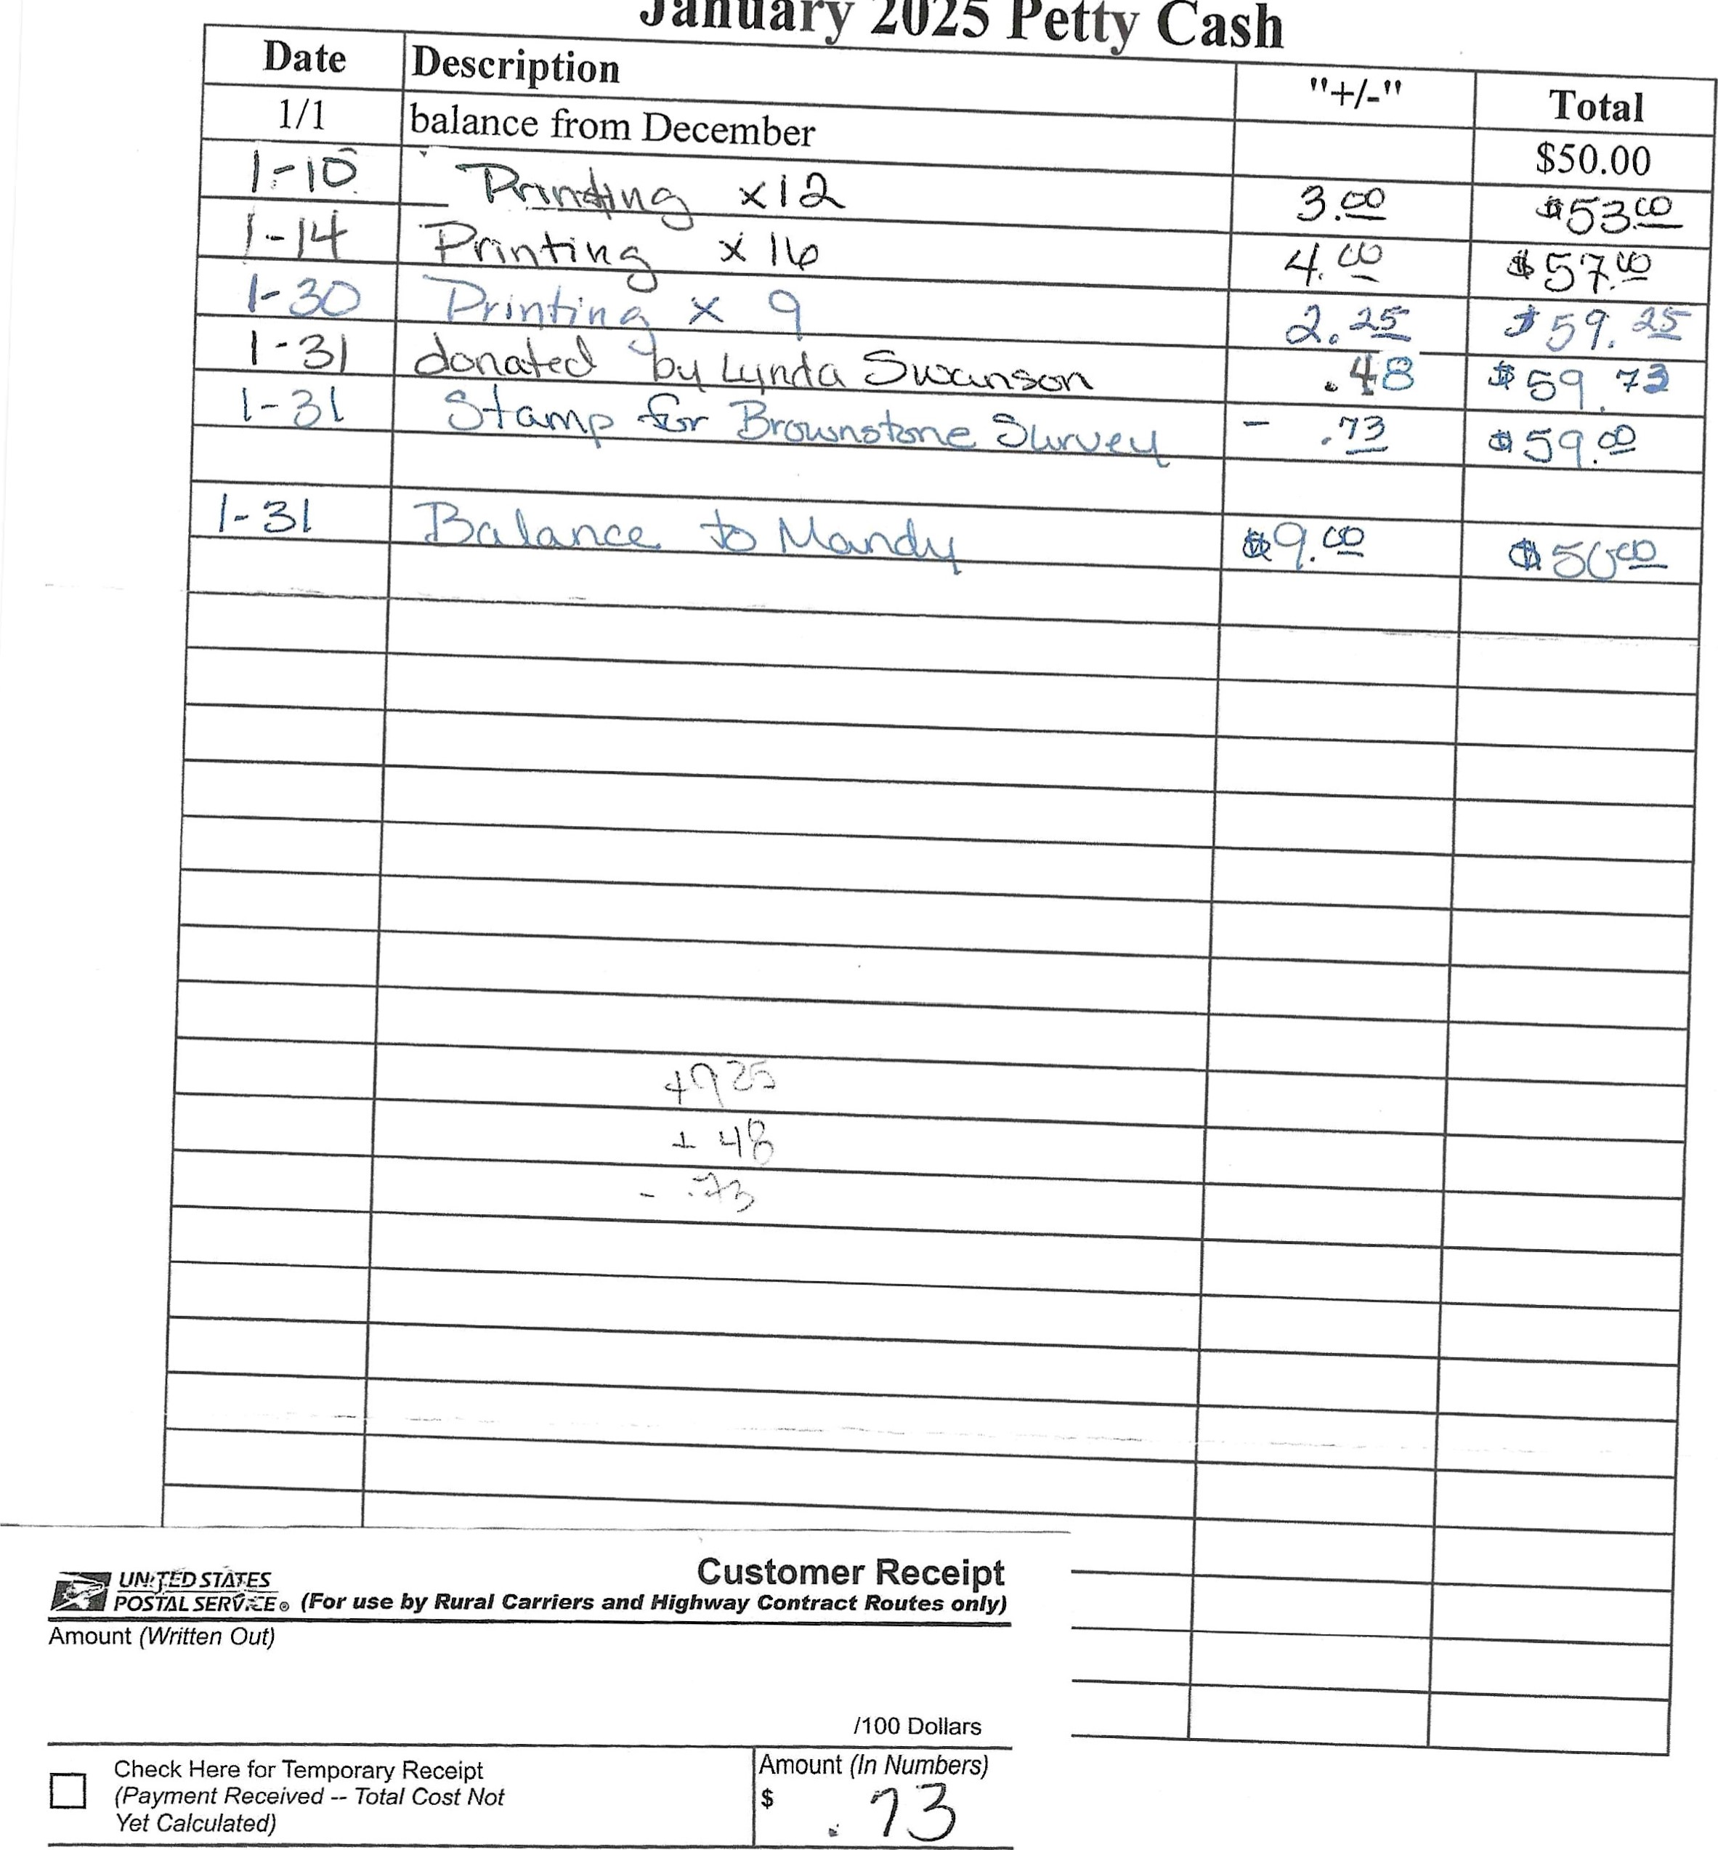
Janua
2025
Pet
Purpose
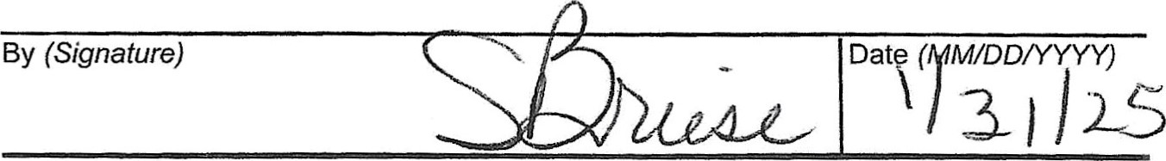
ps Form 1096, October 2009 PSN 7530-02-000-7346

Community
www.ecommunitybank.org
PHONE 712-843-2211 | 208 MAIN ST. | ALBERT CITY IA 50510
PHONE 712-852-2201 | 2407 MAIN ST. | EMMETSBURG, IA 50536
PHONE 712-845-2627 | 102 S. 3RD ST. | LAURENS, IA 50554
PHONE 712-425-3436 | 602 INMAN ST. | MALLARD, IA 50562
PHONE 712-283-2593 | 123 MAIN ST. | SIOUX RAPIDS, IA 50585
PHONE 712-262-3030 | 1812 HWY BLVD. | SPENCER, IA 51301
PHONE 712-838-4321 | 115 MAIN ST. | WEBB, IA 51366 | MEMBER FDIC
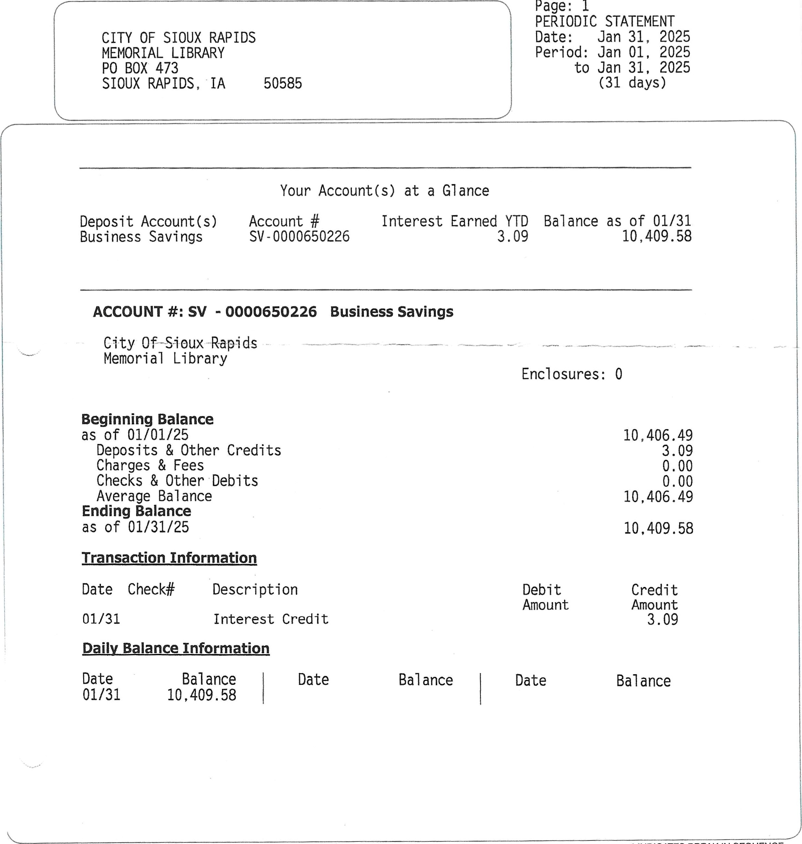
In case of error or questions about your electronic transfers - see reverse side. * INDICATES BREAK IN SEQUENCE

BUDGET REPORT
CALENDAR 1/2025, FISCAL
 | TOTAL | MTD | YTD | PERCENT
ACCOUNT | BUDGET | BALANCE | BALANCE | EXPENDED | UNEXPENDED

001-410-6010 | LIBRARY WAGES FULL TIME | 25,300.00 | .00 | 11, 345.51 | 44.84 | 13,954.49
001-410-6020 | LIBRARY WAGES PART TIME | 9,052.00 | 502.13 | 3,407.80 | 37.65 | 5,644.20
001-410-6240 | LIBRARY MEETING/MILEAGE EXP | 800.00 | .00 | 204.01 | 25.50 | 595.99
001-410-6310 | LIBRARY BUILDING MAINTENANCE | 1,000.00 | .00 | 43.11 | 4.31 | 956.89
001-410-6371 | LIBRARY UTILITIES | 3,400.00 | 361.05 | 1,564.96 | 46.03 | 1,835.04
001-410-6373 | LIBRARY TELEPHONE | 1,000.00 | 57.48 | 439.03 | 43.90 | 560.97
001-410-6499 | OTHER CONTRACTUAL SERV | 3,600.00 | 105.31 | 3,367.72 | 93.55 | 232.28
001-410-6502 | LIBRARY MATERIALS | 4,000.00 | 89.12 | 2,022.16 | 50.55 | 1,977.84
001-410-6507 | LIBRARY OPERATING SUPPLIES | 4,000.00 | .00 | 410.92 | 10.27 | 3,589.08
001-410-6508 | POSTAGE | 120.00 | .00 | 19.83 | 16.53 | 100.17
001-410-6599 | LIBRARY FUNDRAISER | 500.00 | .00 | .00 | .00 | 500.00
001-410-6770 | LIBRARY CAPITAL OUTLAY | 1,000.00 | .00 | .00 | .00 | 1,000.00
001-410-6771 | LIBRARY CAPITAL IMPROVEMENT | .00 | .00 | 2,482. 31 | .00 | 2,482.31
112-410-6110 | LIBRARY FICA - CITY SHARE | 2,628.00 | 38.41 | 1,128.66 | 42.95 | 1,499.34
112-410-6130 | LIBRARY IPERS - CITY SHARE | 3,243.00 | 47.40 | 1, 392 .69 | 42.94 | 1,850.31
300-410-6770 | LIBRARY CAPITAL IMPROVEMENT | .00 | .00 | .00 | .00 | .00

27,828.71 | 46.66
27,828.71 | 46.66

DIFFERENCE 59,643.00 1,200.9031, 814.29

PROOF 59,643.00 1,200.9031,814.29
GLBUDGRP 00

REVENUE REPORT
CALENDAR 1/2025, FISCAL
BUDGET MTD YTD PERCENT

ACCOUNT ESTIMATE BALANCE BALANCE RECVD UNCOLLECTED

001-410-4300 | INTEREST | 25.00 | 3.09 | 22.48 | 89.92 | 2.52
001-410-4310 | LIBRARY RENTAL FEES | .00 | .00 | .00 | .00 | .00
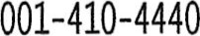 | ENRICH IOWA LIBRARY GRANT | 700.00 | .00 | 797.36 | 113, 91 | 97.36
001-410-4441 | BV CO Founddation Grant | .00 | .00 | .00 | .00 | .00
001-410-4470 | LIBRARY SERVICE CONTRACT | 8,300.00 | .00 | 4,173.50 | 50.28 | 4,126.50
001-410-4700 | LIBRARY CONTRIBUTIONS | 500.00 | .00 | 50.00 | 10.00 | 450.00
001-410-4705 | LIBRARY DONATIONS | 2,500.00 | .00 | .75 | .03 | 2,499.25
001-410-4799 | LIBRARY MISC REVENUE | 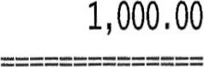 | 46.37 | 276.12 | 27.61 | 723.88
, 320. 21 | 40.85
, 320. 21 | 40.85

DIFFERENCE 13,025.00 49.467, 704.79

PROOF 13 , 025.00 49.467,704.79
GLREVNRP 00

REVENUE & EXPENSE
CALENDAR 112025, FISCAL
MTD YTD

ACCOUNT BALANCE BALANCE BUDGET DIFFERENCE

LIBRARY DEPARTMENT

001-410-4300 | INTEREST | 3.09 | 22.48 | 25.00 | 2.52
001-410-4310 | LIBRARY RENTAL FEES | .00 | .00 | .00 | .00
001-410-4440 | ENRICH IOWA LIBRARY GRANT | .00 | 797.36 | 700.00 | 97.36
001-410-4441 | BV CO Founddation Grant | .00 | .00 | .00 | .00
001-410-4470 | LIBRARY SERVICE CONTRACT |  | 4,173.50 | 8,300.00 | 4,126.50
001-410-4700 | LIBRARY CONTRIBUTIONS | .00 | 50.00 | 500.00 | 450.00
001-410-4705 | LIBRARY DONATIONS | .00 | .75 | 2, 500.00 | 2,499.25
001-410-4799 | LIBRARY MISC REVENUE | 46.37 | 276.12 | 1,000.00 | 723.88
GENERAL TOTAL | 49.46 | 5,320.21 | 13,025.00 | 7,704.79

TOTAL OF ALL REVENUE 49.46 5,320.21 13,025.00 7,704.79
GLRVEXRP 00 Report Format: REVENUE

GIL REVENUE HISTORY
FROM 01/2025 TO 112025
ACCOUNT NUMBER ACCOUNT NAME (FISCAL 7/2025 TO 7/2025)

DATE JOURNAL RECEIVED FROM/ALPHA ID RECEIPT NO REF/DESCRIPTION AMOUNT

001-410-4300 INTEREST

1/31/25 GL2692 COMMUNITY STATE BANK LIB MM INTERST 3.09
ACCOUNT TOTAL 3.09
001-410-4799 LIBRARY MISC REVENUE

1/28/25 GL2686 THRIFT BOOKS LIBRARY COLLECT 46.37
BOOKS SOLD

Check Number 9907967618
ACCOUNT TOTAL 46.37

REPORT TOTAL
49.46
GLREVHRP 07.01.21 City of Sioux Rapids IA OPEN. AC

REVENUE & EXPENSE 1
CALENDAR 1/2025, FISCAL 712025

PCT OF FISCAL YTD 58.3%
MTD YTD
ACCOUNT NUMBER ACCOUNT TITLE BALANCE BALANCE BUDGET DIFFERENCE

LIBRARY DEPARTMENT

001-410-6010 | LIBRARY WAGES FULL TIME | .00 | 11, 345.51 | 25, 300.00 | 13,954.49
001-410-6020 | LIBRARY WAGES - PART TIME | 502.13 | 3,407.80 | 9,052.00 | 5,644.20
001-410-6240 | LIBRARY MEETING/MILEAGE EXP | .00 | 204.01 | 800.00 | 595 . 99
001-410-6310 | LIBRARY BUILDING MAINTENANCE | .00 | 43.11 | 1,000.00 | 956.89
001-410-6371 | LIBRARY UTILITIES | 361.05 | 1, 564.96 | 3,400.00 | 1,835 .04
001-410-6373 | LIBRARY TELEPHONE | 57.48 | 439.03 | 1,000.00 | 560.97
001-410-6499 | OTHER CONTRACTUAL SERV | 105.31 | 3,367.72 | 3,600.00 | 232.28
001-410-6502 | LIBRARY MATERIALS | 89.12 | 2,022.16 | 4,000.00 | 1,977.84
001-410-6507 | LIBRARY OPERATING SUPPLIES | .00 | 410.92 | 4,000.00 | 3,589.08
001-410-6508 | POSTAGE | .00 | 19.83 | 120.00 | 100, 17
001-410-6599 | LIBRARY FUNDRAISER | .00 | .00 | 500.00 | 500. oo
001-410-6770 | LIBRARY CAPITAL OUTLAY | .00 | .00 | 1,000.00 | 1,000.00
001-410-6771 | LIBRARY CAPITAL IMPROVEMENT | .00 | 2,482.31 | .00 | 2,482.31
LIBRARY TOTAL | 1,115.09 | 25,307.36 | 53,772.00 | 28,464.64
GENERAL TOTAL | 1,115.09 | 25,307.36 | 53,772.00 | 28,464.64

112-410-6110 LIBRARY FICA - CITY SHARE 38.41 1,128.66 2,628.00 1,499.34 112-410-6130 LIBRARY IPERS - CITY SHARE 47.40 1,392.69 3,243.00 1,850.31
LIBRARY TOTAL | 85.81 | 2, 521.35 | 5,871.00 | 3,349.65
EMPLOYEE BENEFITS TOTAL | 85.81 | 2,521.35 | 5,871.00 | 3,349.65

300-410-6770 LIBRARY CAPITAL IMPROVEMENT .00 .00 goo .00
LIBRARY TOTAL | .00 | .00 | .00 | .00
CAPITAL IMPROVEMENT TOTAL | .00 | oo | .00 | .00
TOTAL EXPENSES | 1,200.90 | 27,828.71 | 59, 643.00 | 31,814.29
GLRVEXRP 07/01/21 OPER: AC CITY OF SIOUX RAPIDS Statement Writer: 00 Report Format: EXPENSES

GIL EXPENSE HISTORY 1
FROM 0112025 TO 112025
ACCOUNT NUMBER ACCOUNT NAME (FISCAL 7/2025 TO 7/2025)
DATE JUL NAME/OTHER REFERENCE PO NUMBER INVOICE CHECK NO REF/DESCRIPTION AMOUNT

001-410-6020 LIBRARY WAGES PART TIME

1/20/25 PR0769 PR DT: 1/19/25 502.13
ACCOUNT TOTAL  001-410-6371 LIBRARY UTILITIES |  |  | 502113
1/21/25 AP1995 ALLIANT ENERGY | 6316711000-01/06/25 | 36783 UTILITIES | 361.05
ACCOUNT TOTAL  001-410-6373 LIBRARY TELEPHONE |  |  | 361.05
1/17/25 AP1988 EVERTEK, INC. | JANUARY 01, 2025 | 36774 INTERNET, PHONE FOR LIBRARY | 57.48
ACCOUNT TOTAL  001-410-6499 OTHER CONTRACTUAL SERV |  |  | 57.48
1/21/25 AP1995 GFC LEASING | 100987381 | 36790 COPIER CONTRACT 02/05-03/04/25 | 105.31
ACCOUNT TOTAL  001-410-6502 LIBRARY MATERIALS |  |  | 105.31
1/21/25 AP1995 BAKER & TAYLOR | 2038761190 | 36787 BOOKS | 37.51
1/21/25 AP1995 BAKER & TAYLOR | 2038782105 | 36787 BOOKS | 51.61
ACCOUNT TOTAL  112-410-6110 LIBRARY FICA - CITY SHARE |  |  | 89.12
1/20/25 PR0769 | PR DT: | 1/19/25 | 38.41
ACCOUNT TOTAL  112-410-6130 LIBRARY IPERS | CITY SHARE |  |  | 38.41
1/20/25 PR0769 |  |  | 1/19/25 | 47.40
ACCOUNT TOTAL 47.40
REPORT TOTAL
1,200.90

OPER: AC
GLEXPHRP 07.01.21 City of Sioux Rapids IA

