Board Meeting Minutes March 11, 2025
Present: Denise, Suzie, Dorothy, Jamie

Called to Order: 6:15 pm
A: Approved the minutes: Denise approved, Dorothy 2 ^{nd}
B: Approved monthly bills: Dorothy approved, Denise 2 ^{nd}
C: Board CE classes reported: None to report
D: Prohibition Program—posters displayed, will email different libraries and Wagon Wheel
E: E-rate for new year: All done
F: Paper project next 5 yrs sent to Advantage, all ready to go sealed box sent off
- Changes to open/closing policy—shortened
- Changes to Director/Associate duties and cleaning staff only add 1 line and eliminated a full page
I: Director reporting:
Asked Ranco for donations—Jamie to follow up with Jeff for Daddy-Daughter Dance
Calls into Wagon Wheel for pizza's for Daddy-Daughter Dance
Sioux Foods will donate juice boxes for the Summer Reading Program
Tess will donate fudge jumbles for Daddy-Daughter Dance
Susan Mathe will donate all kinds of dessert items for the Daddy-Daughter Dance Will talk to Beth Frasier to see if she can donate to Daddy-Daughter Dance
Made tickets for Daddy-Daughter Dance April 5th 6 pm to 8 pm; 7 confirmed going
February 151 books catalogued
Mandy ordered book for Prohibition Program
Model Railroaders coming for Summer Reading Program
Will talk to Bruce Ferguson about barrel train rides for kids at Summer Reading Program
Vocational Rehab with kids will be coming back to the library
Books downstairs will be taken to Snooks for indoor Garage Sale
Adjourned: 6:47 pm
Sioux Rapids Memorial Library
MARCH 2025 Claims Report
Bills Paid After Meeting FEBRUARY Meeting

Alliant Energy-02-04-2025 | $424.16
Baker & Taylor | $11.97
Total  Bills Needing Approved for Payment | $436.13
Evertek, Inc. 03-01-2025 | $57.48
Leasing 03/05-04/03/25 | $105,31
iker & Taylor | $26.56
Cynthia Garthoff ( Program Materials) | $60.69

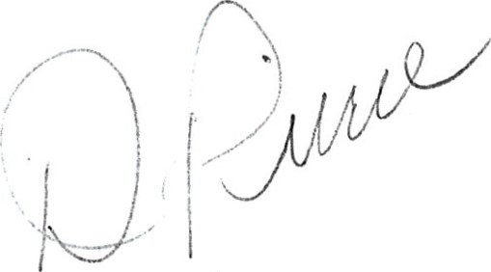
Total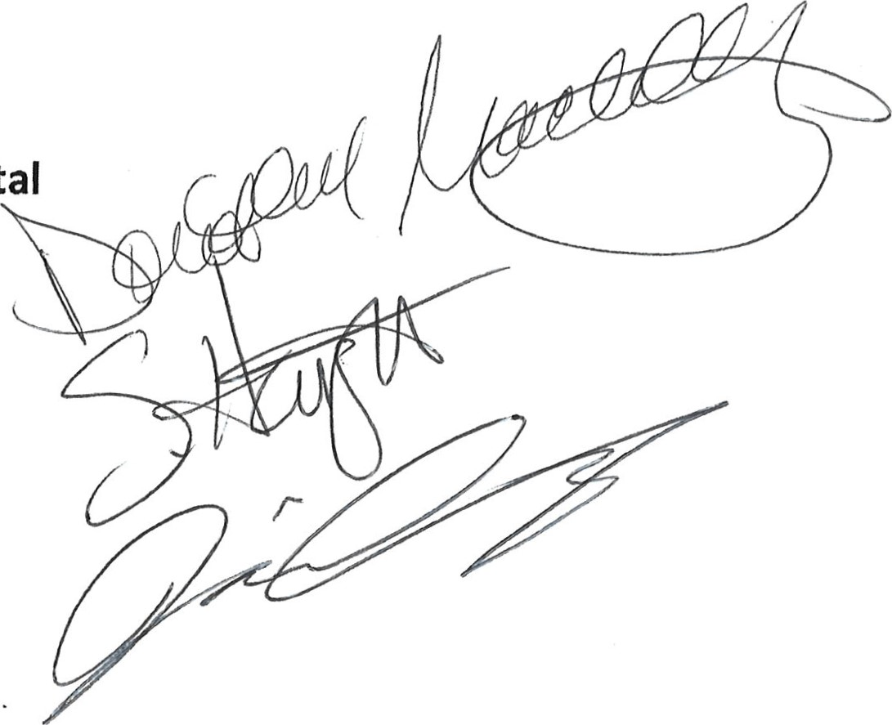 $250.04

Community

www.ecommunitybank.org
PHONE 712-843-2211 208 MAIN ST. ALBERT CITY, IA 50510 PHONE 712-852-2201 2407 MAIN ST. EMMETSBURG, IA 50536 rx-IONE 7 h 2-045-2027O. CT. LAURENS. IA 50554 PHONE 712-425-3436 602 INMAN ST. MALLARD, IA 50562 PHONE 712-283-2593 123 MAIN ST. SIOUX RAPIDS, IA 50585

PHONE 712-262-3030 1812 HWY BLVD. SPENCER, IA 51301
PHONE 712-838-4321 115 MAIN ST. WEBB, IA 51366 MEMBER FDIC
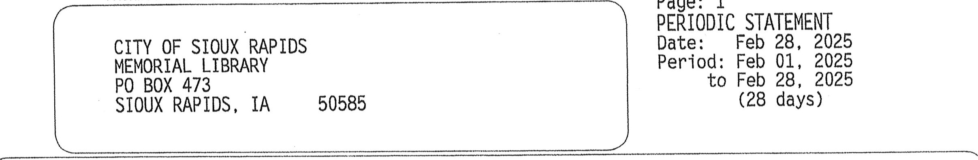
Page:
1


Your Account(s) at a Gl ance
*
INDICATES
BREAK
IN
SEQUENCE
Deposit Account(s) | Account | Interest Earned YTD | Balance as of 02/28
Business Savings | sv -0000650226 | 5.89 | 10,412.38

ACCOUNT SV - 0000650226 Business Savings
City Of SiOUX Rapids
Memorial Library
Beginning Balance as of 02/01/25  Deposits & Other Credits  Charges & Fees  Checks & Other Debits  Average Balance Ending Balance as of 02/28/25  Transaction Information |  | Enclosures: | 10 , 409.58  2.80  0.00  0.00  10,409.58  10 , 412.38
Date Check} Description |  | Debit  Amount | Credit  Amount
02/28 Interest Credit  Daily Balance Information |  |  | 2.80
Date Bal ance Date | Bal ance | Date | Bal ance
02/28 10,412.38
Sioux Rapids Memorial Library
MARCH 2025 Claims Report
Bills Paid After Meeting FEBRUARY Meeting
Alliant Energy-02-04-2025 | $424.16
Baker & Taylor | $11.97

Total $436.13
Evertek, Inc. 03-01-2025 | $57.48
Leasing 03/05-04/03/25 | $105.31
..er & Taylor | $26.56
Cynthia Garthoff ( Program Materials) | $60.69
Total | $250.04
Bills Needing Approved for Payment

O,
CALENDAR 212025, FISCAL 8/2025

TOTAL MTD YTD PERCENT
)UNT NUMBER ACCOUNT BUDGET BALANCE BALANCE EXPENDED UNEXPENDED

-410-6010 LIBRARY WAGES - FULL TIME 25,300.00 1,024.00 12 , 369.51 48.89 12,930.49 -410-6020WAGES PART TIME 759,89 4,167.69 46.04 -410-6240 LIBRARY MEETING/MILEAGE EXP 800.00 .00 204.01 25.50
-410-6310 LIBRARY BUILDING MAINTENANCE 1,000.00 .00 43.11 4.31 956, 89
-410-6371 LIBRARY UTILITIES 3,400.00 424.16 1,989.12 58.50 1,410.88 -410-6373 LIBRARY TELEPHONE 1,000.00 57.48 496.51 49.65 503.49 .-410-6499 OTHER CONTRACTUAL SEW 3,600.00 105.31 3,473.03 96,47 126.97 1-410-6502 LIBRARY MATERIALS 4,000.00 197.49 2,219.65 55.49 1,780.35 1-410-6507 LIBRARY OPERATING SUPPLIES 4,000.00 50.00 460 • 92 11.52 3,539.08 1-410-6508 POSTAGE 120.00 .73 20.56 17.13 99.44 1-410-6599 LIBRARY FUNDRAISER 500.00 .00 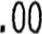 .00 500.00

1-410-6770 LIBRARY CAPITAL OUTLAY 1,000.00 .00 goo .00 1,000.00

1-410-6771 LIBRARY CAPITAL IMPROVEMENT .00 , 00 2,482.31 .00 2,482.31 2-410-6110 LIBRARY FICA CITY SHARE 2,628.00 136.47 1,265.13 48.14 1,362.87 2-410-6130 LIBRARY IPERS - CITY SHARE 3,243.00 168.41 1,561.10 48.14 1,681.90 0-410-6770 LIBRARY CAPITAL IMPROVEMENT .00 .00 .00 .00 .00
30,752.65 | 51.56
30, 752.65 | 51.56

DIFFERENCE 59,643.00 2,923.9428,890.35

PROOF 59,643.00 2,923.9428,890.35
RI IDGRP 07/01121 OPER: AC CITY OF SIOUX RAPIDS 00
February 2025 Petty Cash
Date | Description |  | Total
2/1 | balance from Januaty |  | $50.00
2/4 | Printing x 9 | $2.25 | $52.25
 | Printing x 4 | $1.00 | $53.25
 | Printing x8 | $2.00 | $55.25
2/6 | printing x 2 | $0.50 | $55.75
2/10 | printing x 1 | $0.25 | $56.00
2/17 | Fax x 5 | $5.00 | $61.00
2/19 | Printing x 2 | $0.50 | $61.50
2/20 | Copies x 6 | $1.50 | $63.00
2/28 | Printing x 3 | $0.75 | $63.75
 | Donation | $2.25 | $66.00
 | To Mandy |  | $16.00
 | 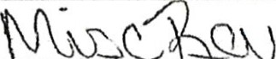

REVENUE REPORT
CALENDAR 212025, FISCAL 8/2025
BUDGET MTD YTD PERCENT ESTIMATE RECVD

.410-4300 INTEREST 25.00 2,80 25.28 101.12 .28-410-4310RENTAL FEES .00 .00 .00 .00 .00 -410-4440 ENRICH IOWA LIBRARY GRANT 700.00 .00 797.36 113.91 97.36-410-4441 BV CO Founddation Grant .00 .00 .00 .00 .00 -410-4470 LIBRARY SERVICE CONTRACT 8,300.00 .00 4,173.50 50.28 4,126.50 -410-4700 LIBRARY CONTRIBUTIONS 500.00 , 00 50.00 10.00 450.00 -410-4705 LIBRARY DONATIONS 2,500.00 .48 1.23 .05 2,498.77 -410-4799 LIBRARY MISC REVENUE 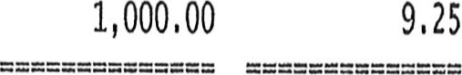 285.37 28.54 714.63
5,332.74 | 40.94
5,332.74 | 40.94

DIFFERENCE 13,025.00 12.537,692.26 PROOF 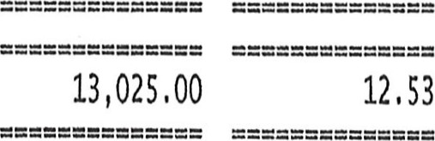 7,692.26

f*1TV IY RAPIDS 00

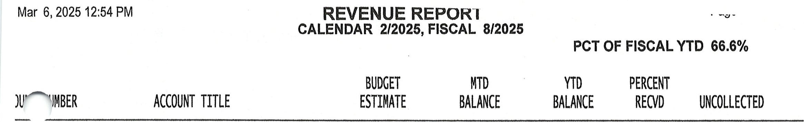

-410-4300 INTEREST 25.00 2,80 25.28 101.12 .28-410-4310 LIBRARY RENTAL FEES .00 .00 , 00 .00 .00 -410-4440 ENRICH IOWA LIBRARY GRANT 700.00 .00 797.36 113.91 97.36 -410-4441 BV CO Founddation Grant .00 .00 .00 .00 -410-4470 LIBRARY SERVICE CONTRACT .00 4,173.50 50.28 4,126. 50 -410-4700 LIBRARY CONTRIBUTIONS 500.00 , 00 50.00 10.00 450.00
-410-4705 LIBRARY DONATIONS 2,500.00 .48 1. 23 .05 2,498.77 .-410-4799 LIBRARY MISC REVENUE 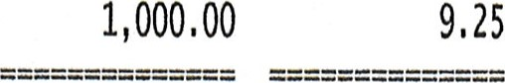9.25 285.37 28.54 714.63
5,332.74 | 40.94
5,332.74 | 40.94

DIFFERENCE 13,025.00 12. 537,692.26

PROOF 13 , 025.00 12. 537,692.26
r:' 071M 124 OPER: ACOF SIOUX RAPIDS 00
REVENUE & EXPENSE Nerum 1
CALENDAR 212025, FISCAL 8/2025
MTD YTD
OUNT NUMBER ACCOUNT BALANCE BALANCE BUDGET DIFFERENCE

LIBRARY DEPARTMENT
-410-6010 LIBRARY WAGES - FULL TIME 1,024.00 12 , 369.51 25 , 300.00 12,930.49 .-410-6020 LIBRARY WAGES - PART TIME 759,89 4,167.69 9,052.00 4,884.31 .-410-6240 LIBRARY MEETING/MILEAGE EXP .00 204.01 800.00 595.99 .-410-6310 LIBRARY BUILDING MAINTENANCE .00 43.11 1,000.00 956.89 .-410-6371 LIBRARY UTILITIES 424.16 1,989.12 3,400.00 1,410.88 1-410-6373 LIBRARY TELEPHONE 57.48 496.51 1,000.00 503.49 1-410-6499 OTHER CONTRACTUAL SERV 105.31 3,473.03 3,600.00 126.97 1-410-6502 LIBRARY MATERIALS 197.49 2,219.65 4,000.00 1,780.35 1-410-6507 LIBRARY OPERATING SUPPLIES 50.00 460 • 92 4,000.00 3,539.08 1-410-6508 POSTAGE .73 20.56 120.00 99.44 1-410-6599 LIBRARY FUNDRAISER .00 .00 500.00 500.00

1-410-6770 LIBRARY CAPITAL OUTLAY .00 .00 1,000.00 1-410-6771 LIBRARY CAPITAL IMPROVEMENT .00 2,482.31 .00 2,482.31

LIBRARY TOTAL 2,619.06 27,926.4253,772.00 25,845.58

GENERAL TOTAL 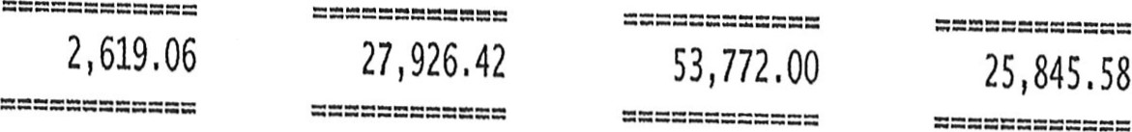
.2-410-6110 | LIBRARY FICA - CITY SHARE | 136.47 | 1,265.13 | 2,628.00
.2-410-6130 | LIBRARY IPERS - CITY SHARE  LIBRARY TOTAL | 168.41  304.88 | 1,561.10  2,826.23 | 3,243.00  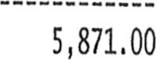 | 1,681.90  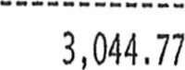

EMPLOYEE BENEFITS TOTAL 304.88 2,826.23 5,871.00 3,044.77

00-410-6770 LIBRARY CAPITAL IMPROVEMENT .00 .00 .00 .00
LIBRARY TOTAL | .00 | goo | , 00 | .00
CAPITAL IMPROVEMENT TOTAL .00 .00 .00 , 00

TOTAL EXPENSES 2,923.94 30,752.65 59,643.00 28,890.35
r.rrv ne IV QA Dins 00 Report Format: EXPENSES

REVENUE 1110 1
FROM 02/2025 TO 212025

(FISCAL 8/2025 TO 8/2025)

-410-4300 INTEREST

2/28/25 GL270i COMMUNITY STATE
ACCOUNT TOTAL

.-410-4705 LIBRARY DONATIONS
2/03/25 GL2688 PETTY CASH JANUARY
ACCOUNT TOTAL

1-410-4799 LIBRARY MISC REVENUE 2/03/25 GL2688 PETTY CASH JANUARY
ACCOUNT TOTAL
LREVHRP 07.01.21
LIB MM INTERST 2.80
2.80

LIBRARY COLLECT .48

PETTY CASH JANUARY 2025
.48

LIBRARY COLLECT 9.25

PETTY CASH JANUARY 2025
9.25

REPORT TOTAL
12. 53

OPER: AC
City of Sioux Rapids IA

EXPENSE HISTORY I
FROM 02/2025 TO 212025

(FISCAL 8/2025 TO 8/2025)
PO NUMBER INVOICE

-410-6010 LIBRARY WAGES - FULL TIME

17/25 PRO/78 PR DT: 2/16/25 1024, 00
ACCOUNT TOTAL  .-410-6020 LIBRARY WAGES - PART TIME |  |  | 1,024.00
'03/25 PR0774 |  | 2/02/25 | 461.96
'17/25 PR0778 |  | 2/16/25 | 297.93
ACCOUNT TOTAL  1-410-6371 LIBRARY UTILITIES |  |  | 759.89
(19/25 AP2004 ALLIANT ENERGY | 6316711000-02/04/25 | 36833 UTILITY | 424.16
ACCOUNT TOTAL  1-410-6373 LIBRARY TELEPHONE |  |  | 424.16
/06/25 AP2002 EVERTEK, INC. | 02/01/2025 | 36817 LIBRARY INTERNET & PHONE | 57.48
ACCOUNT TOTAL 57.48
1-410-6499 OTHER CONTRACTUAL SEW
ACCOUNT TOTAL  01-410-6507 LIBRARY OPERATING SUPPLIES |  |  | 197.49
2/19/25 AP2004 HRS HANIGAN | 0158 | SPEAKER FEE | 50.00

/19/25 AP2004 CFC LEASING 100995828 36839 COPIER CONTRACT 03/05-04/04/25 105.31
ACCOUNT TOTAL  )1-410-6502 LIBRARY MATERIALS |  |  | 105.31
!/19/25 AP2004 BAKER & TAYLOR |  | 36837 BOOKS | 34,97
M19/25 AP2004 BAKER & TAYLOR | 2038837721 | 36837 BOOKS | 150.55
2/19/25 AP2004 BAKER & TAYLOR | 2038864208 | 36837 BOOKS | 11.97
ACCOUNT TOTAL |  | 50.00
01-410-6508 POSTAGE | PETTY CASH JANUARY 2025 | .73
2/03/25 GL2688 LIBRARY P/C EXP | PETTY CASH EXPENSE
2/03/25 GL2690 LIBRARY P/C EXP | PETTY CASH JANUARY 2025 PETTY CASH EXPENSE | .73
2/03/25 GL2690 LIBRARY P/C EXP | PETTY CASH JANUARY 2025 PETTY CASH EXPENSE | .73-
ACCOUNT TOTAL |  |  | .73
12-410-6110 LIBRARY FICA - CITY SHARE |  | 2/02/25 | 35.34
25 PR0774 |   DT: |  | 101.13
PR0778 | PR | 2/16/25

OPER: AC
EXPENSE HISTORY NEPUN I
FROM 02/2025 TO 2/2025

(FISCAL 8/2025 TO 8/2025)
ATE NAME/OTHER REFERENCE PO NUMBER INVOICE CHECK NO REF/DESCRIPTION AMOUNT

-410-6110 LIBRARY FICA - CITY SHARE

1-410-6130 | ACCOUNT TOTAL  LIBRARY IPERS - CITY SHARE |  |  | 136.47
¹03/25 PR0774 |  |  | 2/02/25 | 43.61
¹17/25 PR0778 |  | PR DT: | 2/16/25 | 124.80
ACCOUNT TOTAL 168.41

REPORT TOTAL

2,923.94
BYPHRP 07.01.21
Cifu of Sioux Raoids IA OPER: AC

