Sioux Rapids Memorial Library

AGENDA: LIBRARY BOARD MEETING
Tuesday, January 14, 2025 at 6 p.m.
At the Sioux Rapids Memorial Library

CALL MEETING TO ORDER

APPROVE AGENDA
  - Approve minutes from previous meeting
  - Approve monthly bills/financial report

DISCUSSION AND ACTION ITEMS
  - Board CE classes reported
  - Possibly will need to get new monitor for the director new computer, will check when the new computer gets here….if yes, what to do with old
  - Prohibition Program discussion/decision
  - Hours library is open
  - Board officers Election for new calendar year
  - Update/Approve Job Add for Director position/where advertise/how long?
  - Budget for FY 2026 done
  - Director report from Bethany – as of Dec 23rd, 2024
  - Erate for new year, finalized all paperwork or no?
  - Town meeting for moving FYI only
  - Discuss what we want to see done in the interim… Holly wants priority
  - Lights in library…check out if not done yet
  - Update on computer arrivals?

ADJOURNMENT

Next meeting to be February 11th, 2025 @ 6:00 PM

Minutes January 14, 2025

Roll Call:
Dorothy Machholz |  | present
Jamie Dorenkamp |  | Via phone
Suzie Haight |  | absent
Denise Pierce |  | present
Eric Waldstein |  | present
Lacy Garberding | City Council Liaison (non-voting)
Holly Miller | Library Assoc (non-voting) | present

Meeting called to order at 6:15 pm

PREVIOUS MONTH’S MINUTES
Motion to approve bills by Denise, seconded by Eric, approved unanimously.

Bills
Motion to approve bills Eric, seconded by Denise, approved unanimously.
(See attached)

Discussion and Action Items

Board CE report
 | Date | Training/items to share from training
Dorothy Machholz
Jamie Dorenkamp
Suzie Haight
Denise Pierce
Eric Waldstein

New monitor for director’s computer
All approved if needed

Prohibition program
March 29th @ the theater .. Spencer library is also doing program the same day @ 1pm

adjusted hours until director is hired
Mon-Tues-thurs 2-5 , wed 12-3 and fri 9-12 & closed on sat

Board Officer Elections
President:
Nominations: Dorothy Machholz (include all—last year ran unopposed)
Dorothy Machholz elected by a vote of 3 (not including herself)

Vice President:
Nominations: Jamie Dorenkamp (include all—last year ran unopposed)
Jamie Dorenkamp elected by a vote of 3 (not including himself)

Secretary:
Nominations: Suzie Haight (include all—last year ran unopposed)
Suzie Haight elected by a vote of 4 (not including herself)

Update Job Ad for Director Posting
30-32 Hrs/wk-Local postings ; AD up thru 1-22-25 ; Interviews Wed 1-23-2025 @6:30 PM

Budget
- Proposed budget attached.
- Vote to approve proposed budget for FY 2026:
 | Yes | No | Abstain
Dorothy Machholz | X
Jamie Dorenkamp | X
Suzie Haight
Denise Pierce | X
Eric Waldstein | X

Director’s report read by Dorothy, see attached.

ERATE FOR NEW YEAR,
Do form 471 to complete

TOWN MEETING FOR MOVING FYI ONLY
Public meeting date to be determined

DISCUSS WHAT TO SEE BEING DONE IN INTERIM FOR HOLLY
Get mail, do book returns, drop box & ILL books

LIGHTS IN LIBRARY
City is working on the issue

UPDATE ON COMPUTER ARRIVALS
Three desk tops in building 4th one shipped 1-14-2025

Motion by Denise, seconded by Dorthy, for ADJOURNMENT at: 7:50 pm

Director’s Report – December 23, 2024

(Bethany’s Final Report)
Cataloging update (numbers as of 12-23-2024)
- Total Completed: 7980
- Fiscal 2025: 790
- December 2024: 67

Received:
- Open Access/ILL Reimbursement check-$316
- Shelf with doors from Joy Huegerich (added to DVD section)
- Donation from Michelle Patten in honor of Carole Hollesen - $50
- 100 children’s books received from Brownstone Book Fund

Projects:
- PLA Survey submitted.
- ERATE bid matrix completed—Evertek clear winner for funding year 2025. (Bid matrix attached.)
- Book giveaways @ storytimes— 29 kids received books bringing total to 66 books given away total.
- Brownstone Book Fund grant books checked against shipping list. 1 misprinted—Janee & Debbie notified so another copy can be sent. Waiting on donation labels (sent from Brownstone in November) to finish cataloging. Project explained to Holly. As much paperwork as possible completed (there are survey questions about if the new books bring people into the library). Facebook posts & newspaper copy prepped for January.
- Creating procedure handbook for successor.

November Stats:
- Door Count: 134
- Computer Use: 24 sessions
- New materials (including donations, Brownstone books): 147
- New patrons: 6
- Withdrawn materials: 87
- Reference questions: 32
- Checkouts:
  - Adult materials: 61
  - Serials & magazines: 22
  - Teen materials: 12
  - Children’s materials: 68
  - DVDs: 7
  - ILL: 12
  - Total: 189

Events & Programming:
- There were a total of 25 events during the month of December with a total attendance of 307.
- Passive programs had 124 users in the month of November.

Bethany’s CE report: No CE during December

Upcoming Events and Dates to Remember:
- January 6 (Holly’s first day back).
- January 14 Board Meeting – discuss budget, officer elections
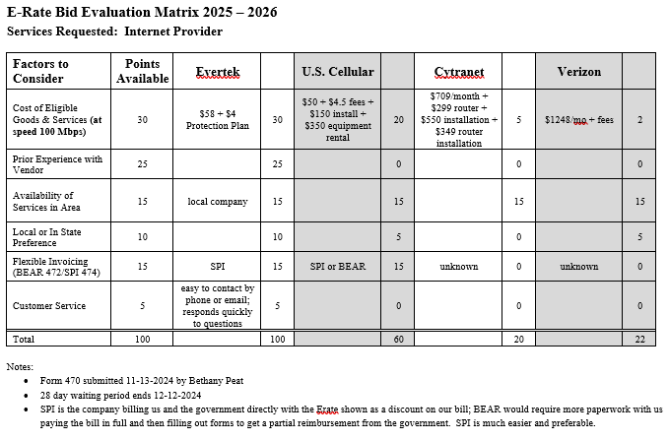

Sioux Rapids Memorial Library JANUARY 2025 Claims Report
Bills Paid After Meeting NOVEMBER Meeting
Alliant Energy-12-03-2024 | $253.00
Evertek-01-01-2025 | $57.48
Total $310.48
Bills Needing Approved for Payment
GCF Leasing | $102.45
aker & Taylor | $37.51
Baker & Taylor | $51.61
HP - Computers | $2,482.31
Total $2,673.88
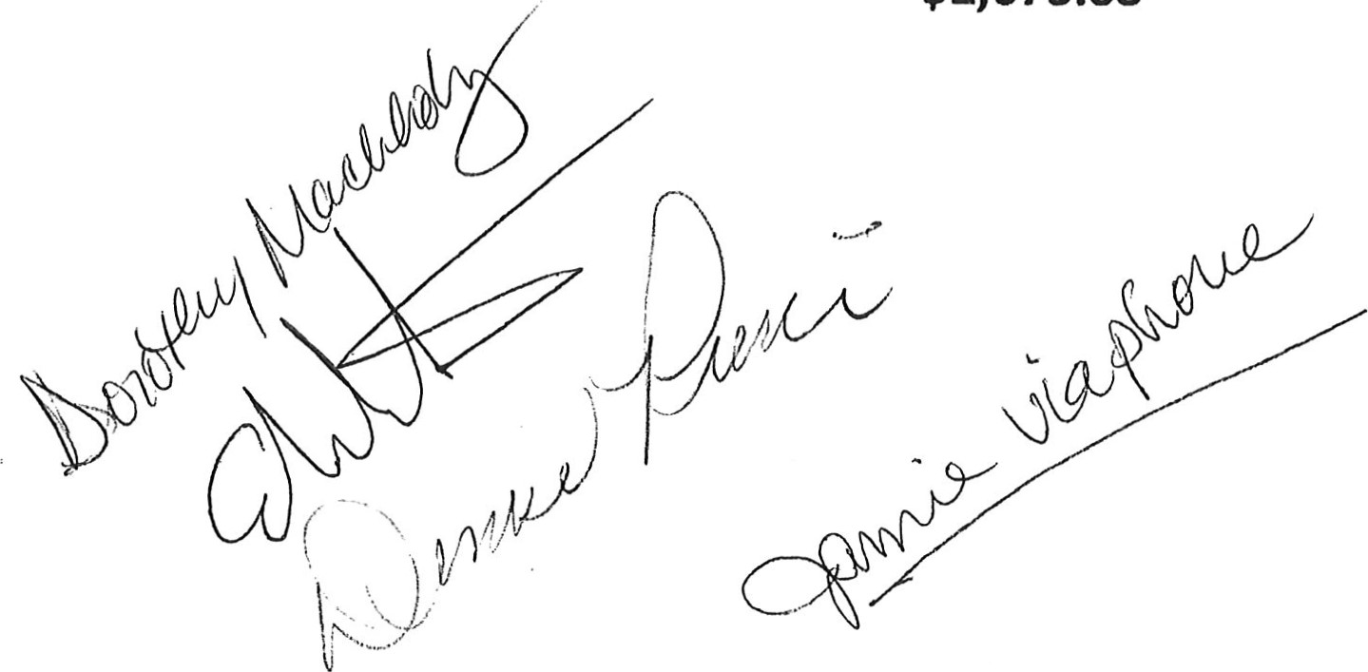

. BUDGET- WORKSHEET Page 1
CALENDAR 1/2025, FISCAL 7/2025
ACCOUNT NUMBER 2 YRS AGO EXP LYR EXPENSE CURRENT BUDGET EXPENDED YTD NEW BUDGET
CCOUNT TITLE
11,345.51
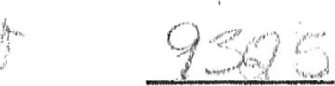
001-410-6020
LIBRARY WAGES PART TIME 7,296.67 9,052.00 2,905.67
001-410-6240
LIBRARY MEETING/MILEAGE EXP  001-410-6310 | 50.69 | 599.32 | 800.00 | 204,01 | 
LIBRARY BUILDING MAINTENANCE  001-410-6371 | 729.25 | 470.29 | 1,000.00 | 43.11 | 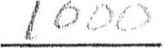
LIBRARY UTILITIES  001-410-6373 | 3,171.37 | 2,755.29 | 3,400.00 | 1,203.91 | 
LIBRARY TELEPHONE | 999.81 | 1,209.12 | 1,000.00 | 381.55 | 
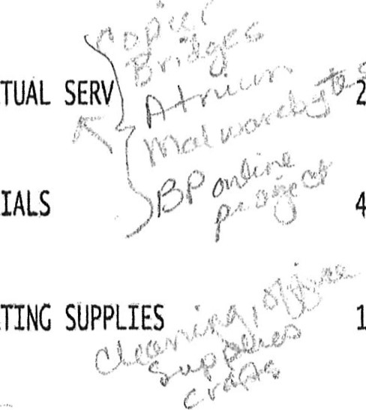

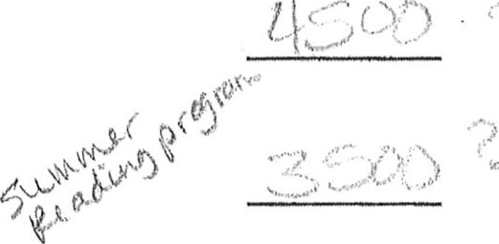
001-410-6499
OPERATING
OTHER CONTRACTUAL SEW i,819.54 3,199.68 3,600.00 3,262.41
001-410-6502
LIBRARY MATERIALS 4,328.45 4,000.00

10-6507
 1,951.05 3,646.34 4,000.00 410.92
001-410-6508
POSTAGE  001-410-6599 | 93.95 | 65.74 | 120.00 | 19.83 | 
LIBRARY FUNDRAISER | 841,71 | 492.70 | 500,00 | .00 | 
001-410-6770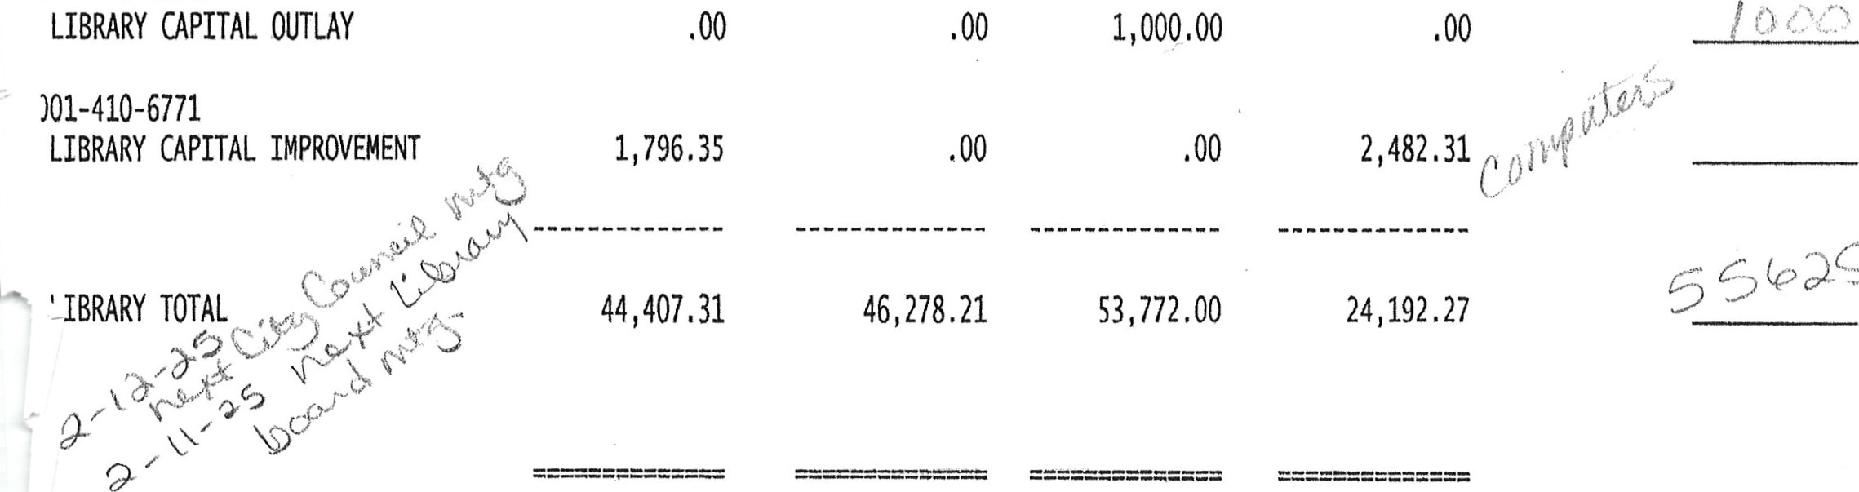

GENERAL TOTAL 44,407.31 46,278.21 53,772.00 24,192.27

Deeper shelving for games & puzzles to be put on/displayed on

.WKSHRP 07/01/21 OPER: AC CITY OF SIOUX RAPIDS Statement Writer. 00 Report Format: EXPENSES

